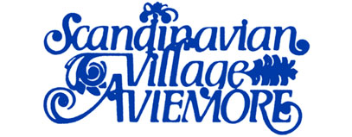
SCANDINAVIAN VILLAGE ASSOCIATION
Scandinavian Village, Aviemore, Inverness-shire PH22 1PF
Telephone: Aviemore (01479) 810500 Fax: (01479) 811604
e-mail: reception@scandinavian-village.co.uk www.scandinavian-village.co.uk

SCANDINAVIAN VILLAGE ASSOCIATION

REGULATIONS IN REGARD TO APPOINTMENT TO COMMITTEE

Each Member listed on the Scandinavian Village Association (“the Association”) Register at the date upon which Notices are despatched will be entitled to nominate another Member or Members of the Association or him or herself as a Member of the Committee of the Association for any vacancy then occurring. Such nomination should be made to the Chairman of the Association for the time being, by no later than the 31 August in such year. If a nominating Member nominates a third party, then a form of consent shall be signed by the Member who is nominated. With each nomination details of the curriculum vitae of the nominated Member shall be provided.

When formal notice of the Annual General Meeting of the Association is given then copies of the details of each candidate shall be supplied to the Membership and a Voting Paper & Form of Proxy will be sent to each Member of the Association to permit the Members who are unable to attend the meeting to vote upon those who have been nominated as prospective Members of the Committee. If the Voting Paper & Form of Proxy has not been returned to the Chairman to arrive by no later than 48 hours before the meeting or such has been incorrectly completed it will be invalid. The determination of the Chairman of the Association for the time being shall be final as to the competence of any such Voting Paper & Form of Proxy returned.

Any candidates nominated for appointment to the Committee will attend the Annual General Meeting and may be asked by the Chairman to address the Members.

No canvassing of Members will be permitted.

Those who fall to be elected shall be those receiving the largest number of votes.

Nominations should be sent to the Registered Office of Scandinavian Village Limited, addressed as follows:

The Chairman
Scandinavian Village Association
C/o Scandinavian Village Limited
Scandinavian Village
AVIEMORE
Inverness-shire
PH22 1PF

